

Have a

tooth that

needs replacing?

fmcw-logo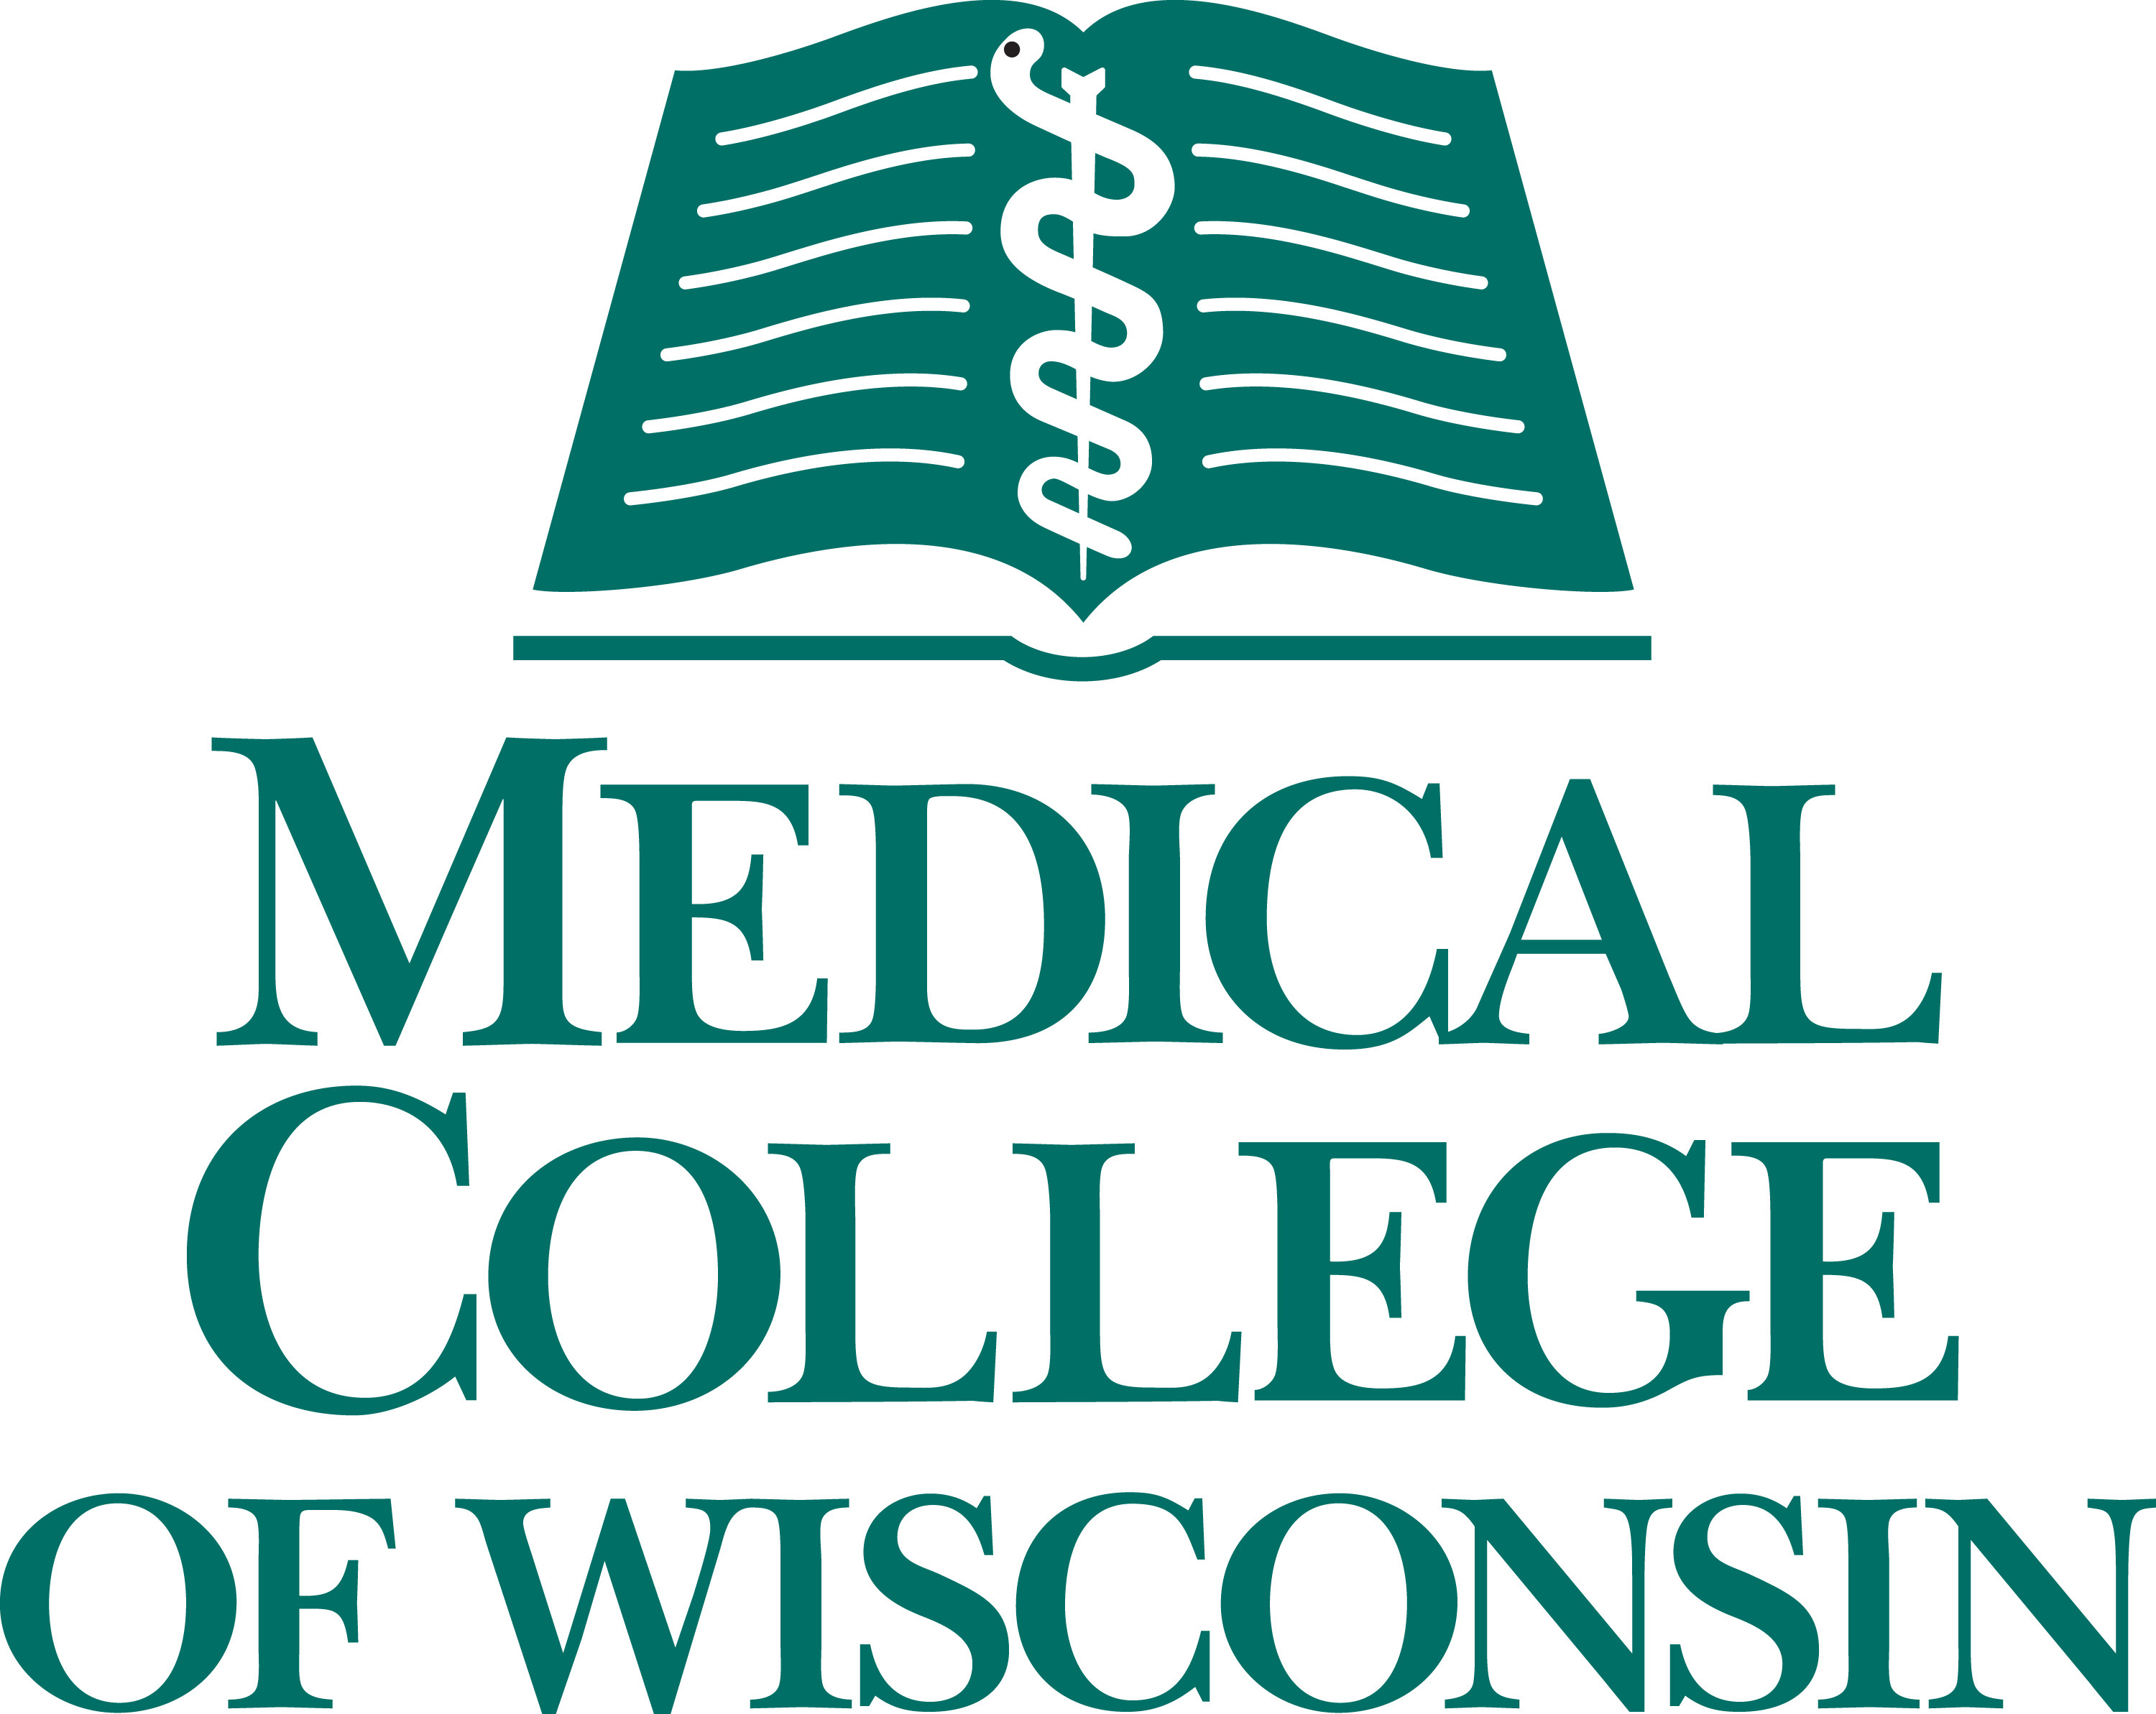

Study Name

(xxx) xxx-xxxx

Email

Study Name

(xxx) xxx-xxxx

Email

Study Name

(xxx) xxx-xxxx

Email

Study Name

(xxx) xxx-xxxx

Email

Study Name

(xxx) xxx-xxxx

Email

Study Name

(xxx) xxx-xxxx

Email

Study Name

(xxx) xxx-xxxx

Email

Study Name

(xxx) xxx-xxxx

Email

If you have a tooth that needs to be extracted and replaced with a dental implant, you may qualify for a tooth socket restoration research study. Researchers at the University of Colorado School of Dental Medicine are evaluating a socket-augmentation procedure that may improve the appearance and functioning of dental implants.

**Qualified participants over age 18 will receive:**

A screening exam

Study-related visits and monitoring by oral surgeons

Compensation will be provided

If you or someone you know would like to learn more,

**contact xxx xxxxxx at (xxx) xxx-xxxx**