REVIEW CRITERIA FOR 2019 CTSI TRADITIONAL PILOT PROPOSALS
GENERAL INSTRUCTIONS FOR SCORING & COMMENTS
- The NIH grant application scoring system uses a 9-point rating scale (1 = exceptional; 9 = poor) in whole numbers (no decimals) for Overall Impact and Criterion scores for all applications.
- NIH expects that scores of 1 or 9 will be used less frequently than the other scores. 5 is for a good medium-impact application and considered an average score.
- No formula is used to derive the overall impact score from the individual criterion scores, and reviewers are instructed to weigh the different criteria as they see fit in deriving their overall scores.
- Note that an application does not need to be strong in all categories to be judged likely to have major scientific impact and thus, deserve a high impact score.
- We ask that you provide meaningful comments within the Strengths and Weaknesses fields which both justify your score and also provide beneficial guidance to the applicant.
Please provide a score and comments in each of the areas below. Note that 1 is the best score possible and 9 is the worst score possible.
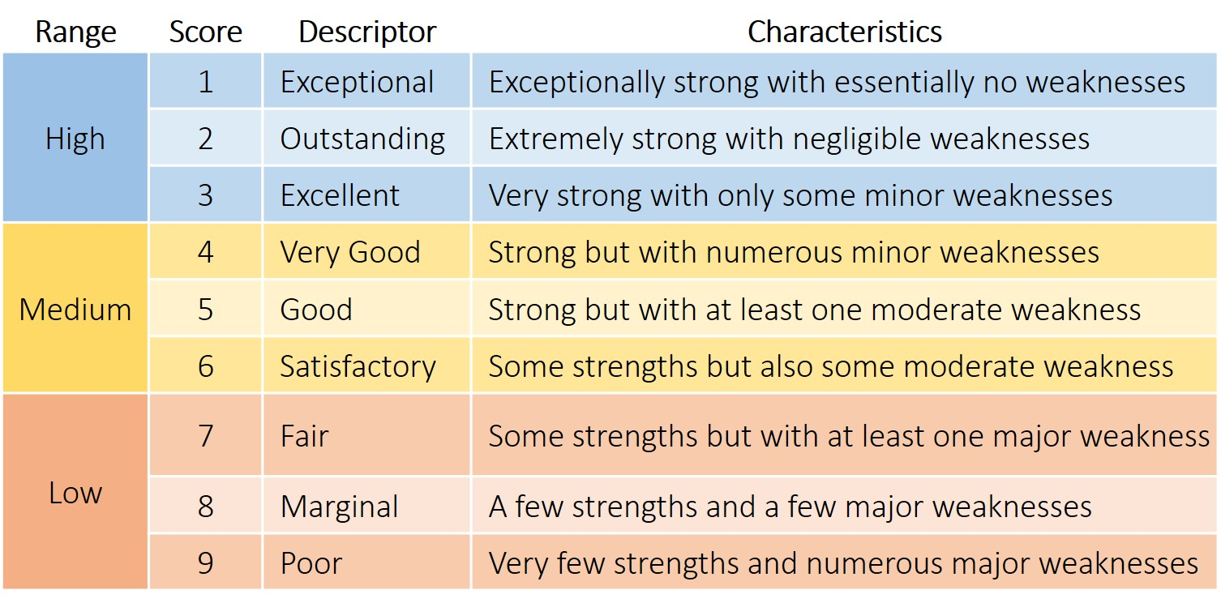

SIGNIFICANCE
Please base your evaluation and score on the following criteria:
- Does the project address an important problem or a critical barrier to progress in the field?
- Is there a strong scientific premise for the project?
- If the aims of the project are achieved, how will scientific knowledge, technical capability, and/or clinical practice be improved?
- How will successful completion of the aims change the concepts, methods, technologies, treatments, services, or preventative interventions that drive this field?
INNOVATION, NOVEL TECHNOLOGY, NOVEL APPROACH
Please base your evaluation and score on the following criteria:
- Does the application challenge and seek to shift current research or clinical practice paradigms by utilizing novel theoretical concepts, approaches or methodologies, instrumentation, or interventions?
- Are the concepts, approaches or methodologies, instrumentation, or interventions novel to one field of research or novel in a broad sense?
- Is a refinement, improvement, or new application of theoretical concepts, approaches or methodologies, instrumentation, or interventions proposed?
- Is there appropriate justification for the proposed work through literature citations, data from other sources, or, when available, from investigator-generated data?
APPROACH & FEASIBILITY
Please base your evaluation and score on the following criteria:
- As written, can this project be accomplished within 12 months?
- Is the overall strategy, methodology, and analyses well-reasoned and appropriate to accomplish the specific aims of the project?
- Have the investigators presented strategies to ensure a robust and unbiased approach, as appropriate for the work proposed?
- Are potential problems, alternative strategies, and benchmarks for success presented?
- If the project is in the early stages of development, will the strategy establish feasibility and will particularly risky aspects be managed?
- Have the investigators presented adequate plans to address relevant biological variables, such as gender?
If the project involves human subjects and/or NIH-defined clinical research:
- Are there plans to address
  - the protection of human subjects from research risks, and
  - the inclusion (or exclusion) of individuals on the basis of sex/gender, race, and ethnicity, as well as the inclusion (exclusion) of children?
- Are these plans justified in terms of the scientific goals and research strategy proposed?
If the project involves recruitment of human subjects:
- Are recruitment strategies well-articulated and workable within the given timeframe?
- Does the project provide alternative measures for dealing with potential recruitment barriers?
ENVIRONMENT
Please base your evaluation and score on the following criteria:
- Will the scientific environment in which the work will be done contribute to the probability of success?
- Is the institutional support, equipment and other physical resources available to the investigators adequate for the project proposed?
- Will the project benefit from unique features of the scientific environment, subject populations, or collaborative arrangements?
- At CTSI, we encourage investigators to maximize CTSI resources. Does the project incorporate other CTSI infrastructure and support, which may include but is not limited to: Biostatistics/Epidemiology Research Design; Clinical Trials Office; i2b2; Image De-Identification Services; IRB Navigator & Regulatory Support Services; REDCap Database Services; Translational Research Units?
TRANSLATIONAL SCIENCE
Please base your evaluation and score on the following criteria:
T-1 Translation to Humans
- How effectively does this research identify and analyze the effects of an intervention or relationship on the human condition or environment?
- How significant are the clinical insights?
T-2 Translation to Patients
- How effectively does this research identify and analyze the optimal effects of an intervention or relationship on the human condition or environment?
- How significant are the implications to practice?
T-3 Translation to Practice
- How effectively does this research incorporate into practice the optimal intervention or relationship?
- Does this research explore ways of applying recommendations or guidelines in general clinical practice or policies?
T-4 Translation to Communities
- How effectively does this research provide communities with the optimal intervention or relationship?
- Will this research result in a true benefit to the community/population of focus?

TEAM SCIENCE
Please base your evaluation and score on the following criteria:
- Do the investigators have complementary and integrated expertise?
- Is the leadership approach, governance and organizational structure appropriate for the project?
- How well does this application fulfill the requirement of being an inter-institutional* and interdisciplinary research team?
* Representative of CTSI partner institutions: BCW; CHW; Froedtert Hospital; MCW; UWM; MU; MSOE; VA
SPECIAL EMPHASIS
This year's special emphasis categories are:
- Community-Engaged Health Disparities Research
- Special Populations Research
Examples include: specific age groups (infants; children; adults; geriatric); survivors of formerly lethal childhood diseases; adults with chronic health conditions that originated in childhood
- Underserved Populations Research
Examples include: Blacks/African Americans; Hispanics/Latinos; American Indians/Alaska Natives; Asian Americans; Native Hawaiians and other Pacific Islanders; socioeconomically disadvantaged populations (low-income communities); rural populations; health disparity populations
NOTE: Research in these areas is not a requirement for the award
Please indicate whether the study involves one or more of this year’s special emphasis areas (the applicant’s response is provided).

OVERALL IMPACT SCORE
Please provide an overall impact score and justification on the likelihood for the project to exert a sustained, powerful influence on the research field(s) involved, in consideration of the preceding review criteria.
Note: An application does not need to be strong in all categories to be judged likely to have major scientific impact.

