
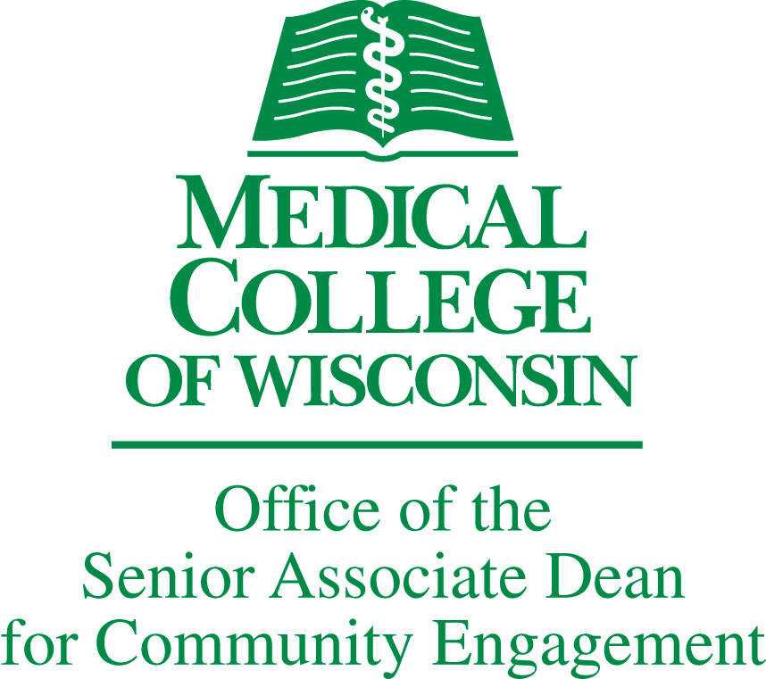

Office of the Senior Associate Dean of Community Engagement and
CTSI Community Engagement Key Function
Community Engagement Week

Friday, April 17, 2015
Medical College of Wisconsin, 8701 Watertown Plank Road, Milwaukee, WI.

CALL FOR POSTERS

SUBMISSION DEADLINE: March 1st, 2015

The Community Engagement Week planning committee is seeking abstract and poster submissions that describe projects, research and/or lessons learned from the field of Community Engagement in Research (CEnR). Relevant submissions will also meet the following criteria:

- All must fit within at least one of the following topic areas
  - community-academic partnerships for health
  - community-centered information systems design
  - metrics and outcomes in CEnR
  - examples from the field in approaching translational research projects
AND

- Either have been developed in direct collaboration with communities (e.g. through a community-academic partnership)
- Or projects demonstrate a deep practical understanding of the needs and priorities of the communities

In contrast to typical academic conferences, posters must convey information about the in ways that are directly accessible and understandable by members of the community at large.

Submission Format. Please complete attached submission form with an abstract (maximum 200 words). We welcome abstracts of original work that have not been peer reviewed previously and those that have been peer reviewed and accepted for presentation at another meeting – but have not yet been presented locally. Complete required information on the abstract form.

Size of actual poster should be 4 feet by 3 feet (horizontal).

Posters that are overly technical, jargon laden or designed solely for an academic audience will be rejected without review.

Electronic Submissions should be sent to mdefino@mcw.edu .

2015 Annual Research Forum
Abstract Submission Form

A. Answer the following about your proposal:

Has this abstract been peer reviewed and accepted for a different meeting? (check): ___YES ___NO
If yes, enter the following:

Meeting: __________________________ Date _____________ Place ___________________

B. Title of Abstract:

C. Author/s First
Additional
(Full names and affiliations)

D. Abstract (Limit to 200 words)

Deadline for Abstract: March 1, 2015
E-mail this completed form to Mia DeFino at mdefino@mcw.edu 414.955.5754.

Thank you.

Accepted posters must still register for the conference.

